# Issue: Order Effective Date needs to be greater than

### Prerequisite:

**Frequency: -** Approx.150 tickets per Month.

**Reference Ticket:** - 256374219, 269672939

**IOM Order** [194631385]

**Dependency:** - GIOM and CADM

**Efforts spends:** - 10 to 15 mins per order.

**Links Required:-**

BVOIP Order Status Tool:

<http://giom.cif.att.com:9001/servlet/ToolsServlet>

DB Detail:-

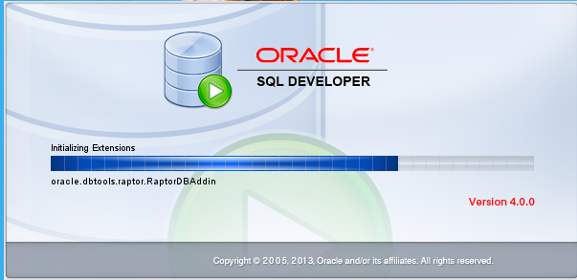

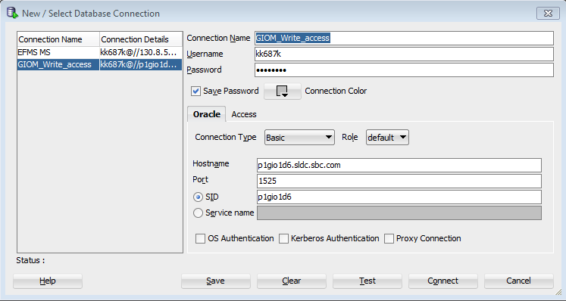

Hostname: p1gio1d6.sldc.sbc.com

Port: 1525

SID: p1gio1d6

# Proactive Script

select io.order_name, so.DATETIME_UPDATED, so.supplier_status, so.ERROR_CODE, so.ERROR_MSG from iomdbo.supplier_order so, iomdbo.iom_order io

where io.iom_order_id = so.iom_order_id

--and io.order_name = '194721508'

and so.DATETIME_UPDATED = (select max(so.DATETIME_UPDATED) as datetime_upd from iomdbo.supplier_order so, iomdbo.iom_order o

where o.iom_order_id = so.iom_order_id

and so.DATETIME_UPDATED > to_date(‘2019/07/28 10:00:00', 'yyyy/mm/dd hh24:mi:ss')

and transaction_name in (71)

and o.iom_order_id = io.iom_order_id)

and so.supplier_status = 1

and so.ERROR_CODE = '875550017'

Once the orders are retrieved using above query, need to validate passing order numbers in step 6 and step 7

Highlighted value will change based on the frequency of the schedule planned.

# Workaround :-

How we pick the Ticket in AOTS exclude HOTCUT Tickets and pick up only Queued tickets?

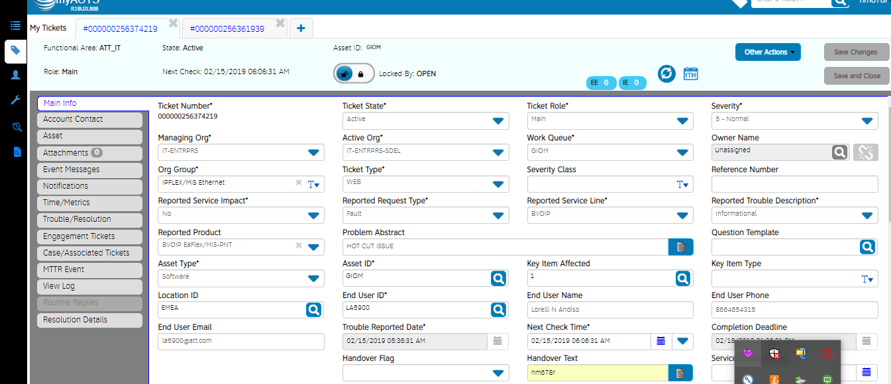

Step 2

Step 1

Step 4

Step 3

## Step 1: Put the ATT UID in handover text.

## Step 2: Select Informational from Reported Trouble Description

## Step 3: Locked the ticket

## Step 4: Save it

How to pick order?

## Step 5: Order is present in main ticket info under Order_number field or in Problem Description.

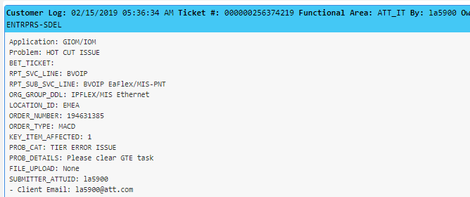

## Step 6:Validate if order is MACD or not :-

Select Order_Name, Decode(A.Acty_Type, 0, 'NS', 174, 'MACD', 175, 'Disconnect', A.Acty_Type) "TYPE"

From Iomdbo.Activity_Dates D,Iomdbo.Activity A,Iomdbo.Iom_Order O, Iomdbo.Voip_Info V

where o.iom_order_id=a.iom_order_id and d.activity_id=a.activity_id and v.iom_order_id=o.iom_order_id

And O.Order_Name In ('194881496');

If the order is NS then automation needs to be skipped. BOA will work manually on NS order.

For order_type = MACD, follow the below steps for workaround.

## 7 Check error through GIOM DB using below script:

select io.order_name, so.DATETIME_UPDATED, so.supplier_status, so.ERROR_CODE, so.ERROR_MSG from iomdbo.supplier_order so, iomdbo.iom_order io

where io.iom_order_id = so.iom_order_id

and io.order_name = '194721508'

and transaction_name in (71);

where supplier_status 1 = Failure

supplier_status 0 = Success

ERROR_MSG:- 8|75550017|Order Effective Date '20190201 000000' needs to be greater than ='20190202 152149'

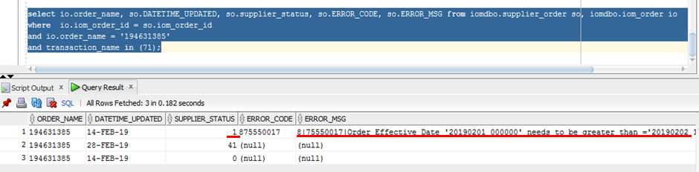

## 7.1 (Optional) Another way to check Error in EFMS GUI

EFMS <url:-> http://efmsms.it.att.com:8008/ms

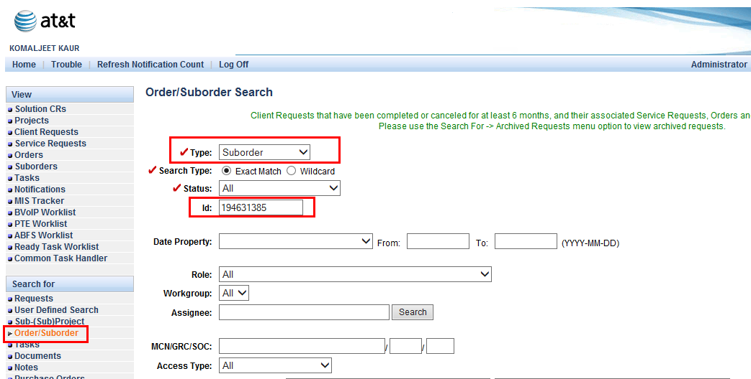

Follow the below steps to check error message and also highlighted main tabs in above screen shot.

1. Click on **Order/Suborder** from “**Search For**”.
2. Select **Suborder** from **Type** filed.
3. Put **order number** in **ID**: field.
4. And click on **Find** Button.
5. Select the radio button corresponding to GTE task and click on Open tab as shown below.

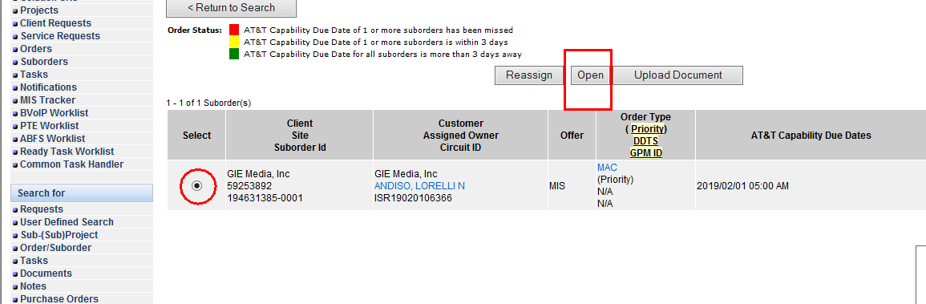

1. Once next screen gets open click on **Suborder Tasks** and then select **Expanded** from **Views** field and click on **Open Task**.

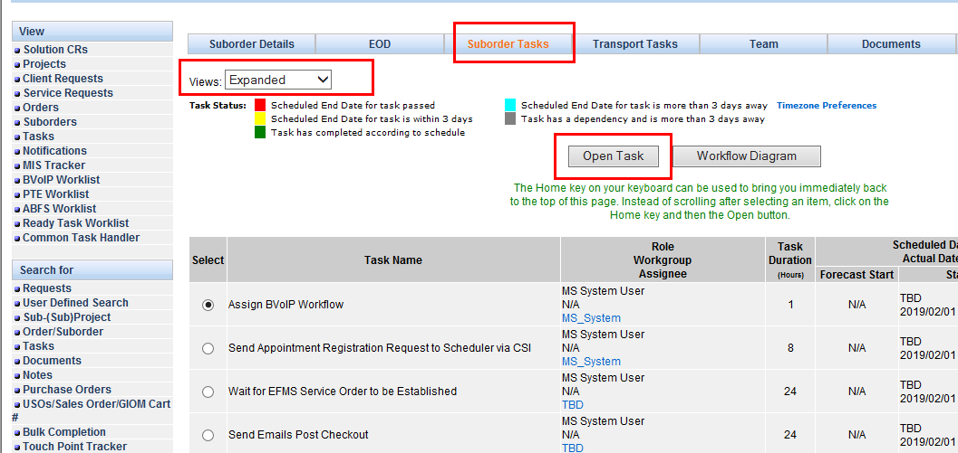

1. Click on Activity Log as shown below

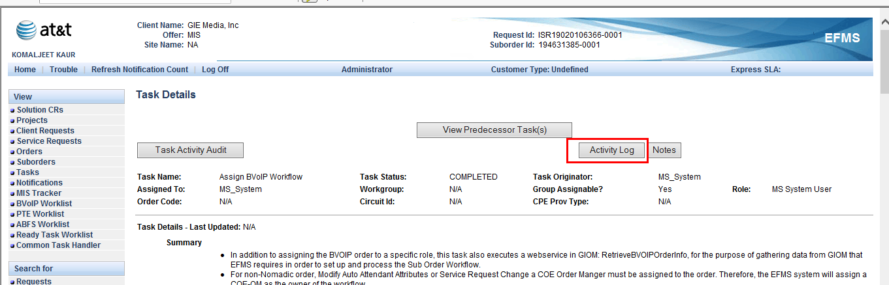

1. You will get below screen

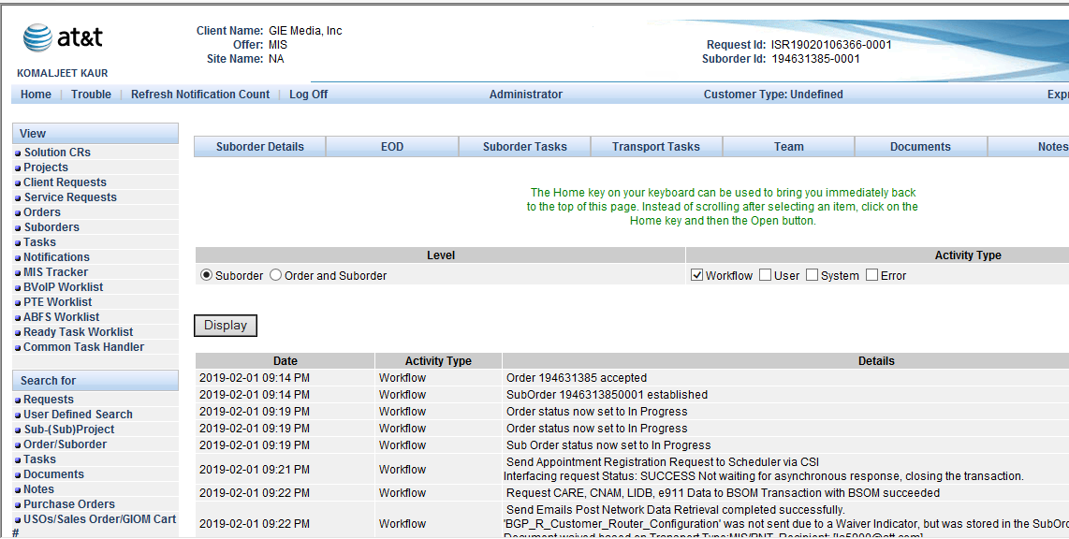

1. Scroll down as and see error message as shown below in screen shot.

this error is related to VOIP_Order Messages</p><p> Validation Error: VOIP_Order.EFF_DT is in the future </p>

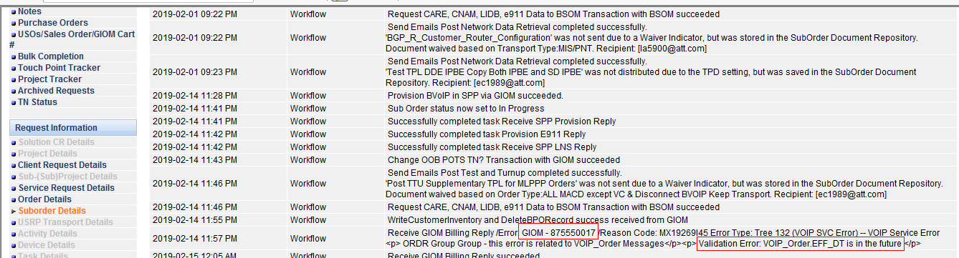

Note:- Optional EFMS steps Ended

## 7.2 (Optional) Go to BVOIP Order Status Tool to view the GIOM Tier Error on Order.

Link of BVOIP Order Status Tool:

http://giom.cif.att.com:9001/JSP/voip/jsp/tools/BvoipToolsMain.jsp

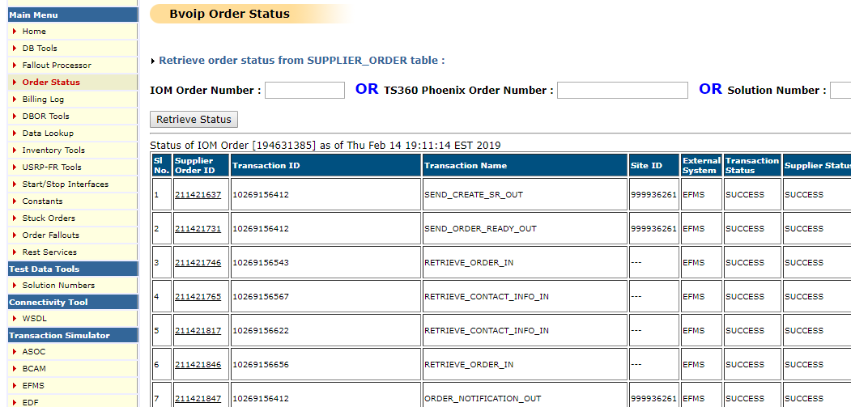

**Step 10**

**Step 9**

**Step 8**

## Step 8: Select Order Status from Main menu

## Step 9: Put the Order Number in IOM Order Number text box.

## Step 10: click on retrieve Status and scroll down to the Billing transactions.

Billing Transactions for the old flow:

SEND_BSE_OUT

SEND_RSC_OUT

SEND_BTF_OUT

PROCESS_BTN_REQUEST

SEND_BTN_OUT  
PROCESS_BTN_RESPONSE

SEND_BILLING_RESULT_BVOIP_OUT

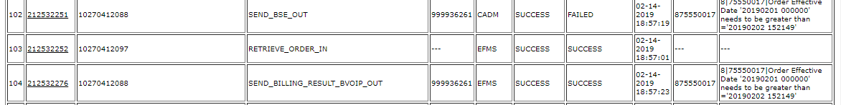

**Step 11**

**Error message**

Note: - Optional GIOM BVOIP order tool steps Ended

## Step 11: Follow below step to update billing Eff Date in EFMS-MS DB.

**Step1:**Billing Date=Billingeffectivedate(from error message corresponding to second Date i.e greater than date )+1day.

### Step2**:** Update the EFMS-MS DB with Billing date from Step1 for order.

EFMS-MS DB Details –

Host Name- p1efm1d7.aldc.att.com

Port – 1524

Script run in EFMS-MS DB:-

update ms_order set billing_effective_date = todate('06-FEB-19','DD-MON-YY') where usrp_order_number = ‘ordernumber’;

### **Step3:** Force Complete the GIOM Tier Error task

If there are multiple GTEs, all the GTEs need to be force completed sequentially.

1. cd /opt/app/home/prodsupp/complete  
  
 2. fc.run (script name)

Please refer below M&P for FC



*Reference to Mnp where task are skipped and fcd*

**Note - Once task is force completed, it can’t be undone.**

#### 

## Step 12:- Wait for 20 mins for transaction to flow.

## Verify billing is success or not using below script. The latest transaction should be success.

select io.order_name, so.DATETIME_UPDATED, so.supplier_status, so.ERROR_CODE, so.ERROR_MSG from iomdbo.supplier_order so, iomdbo.iom_order io

where io.iom_order_id = so.iom_order_id

and io.order_name = '194721508'

and transaction_name in (71);

where supplier_status 1 = Failure

supplier_status 0 = Success

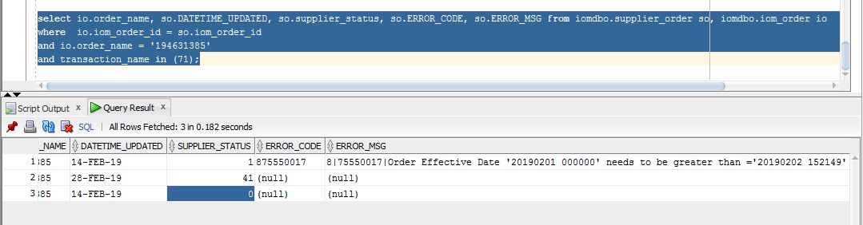

## Step 13:- Need to re-validate from BVOIP order tool for success or failure for error. If it is a success go to Step7.

Check below transaction if they are successful

SEND_BSE_OUT

SEND_RSC_OUT

SEND_BTF_OUT

PROCESS_BTN_REQUEST

SEND_BTN_OUT

PROCESS_BTN_RESPONSE

SEND_BILLING_RESULT_BVOIP_OUT

In case of failure with the same error code validate the date mentioned in error message is different. If its different repeat from step 2 (only once) and for same date update USH logs and send it to BOA for manual workaround.

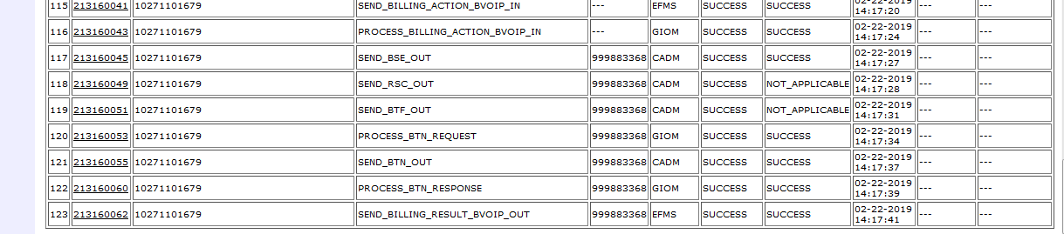

**Issue Resolved.**